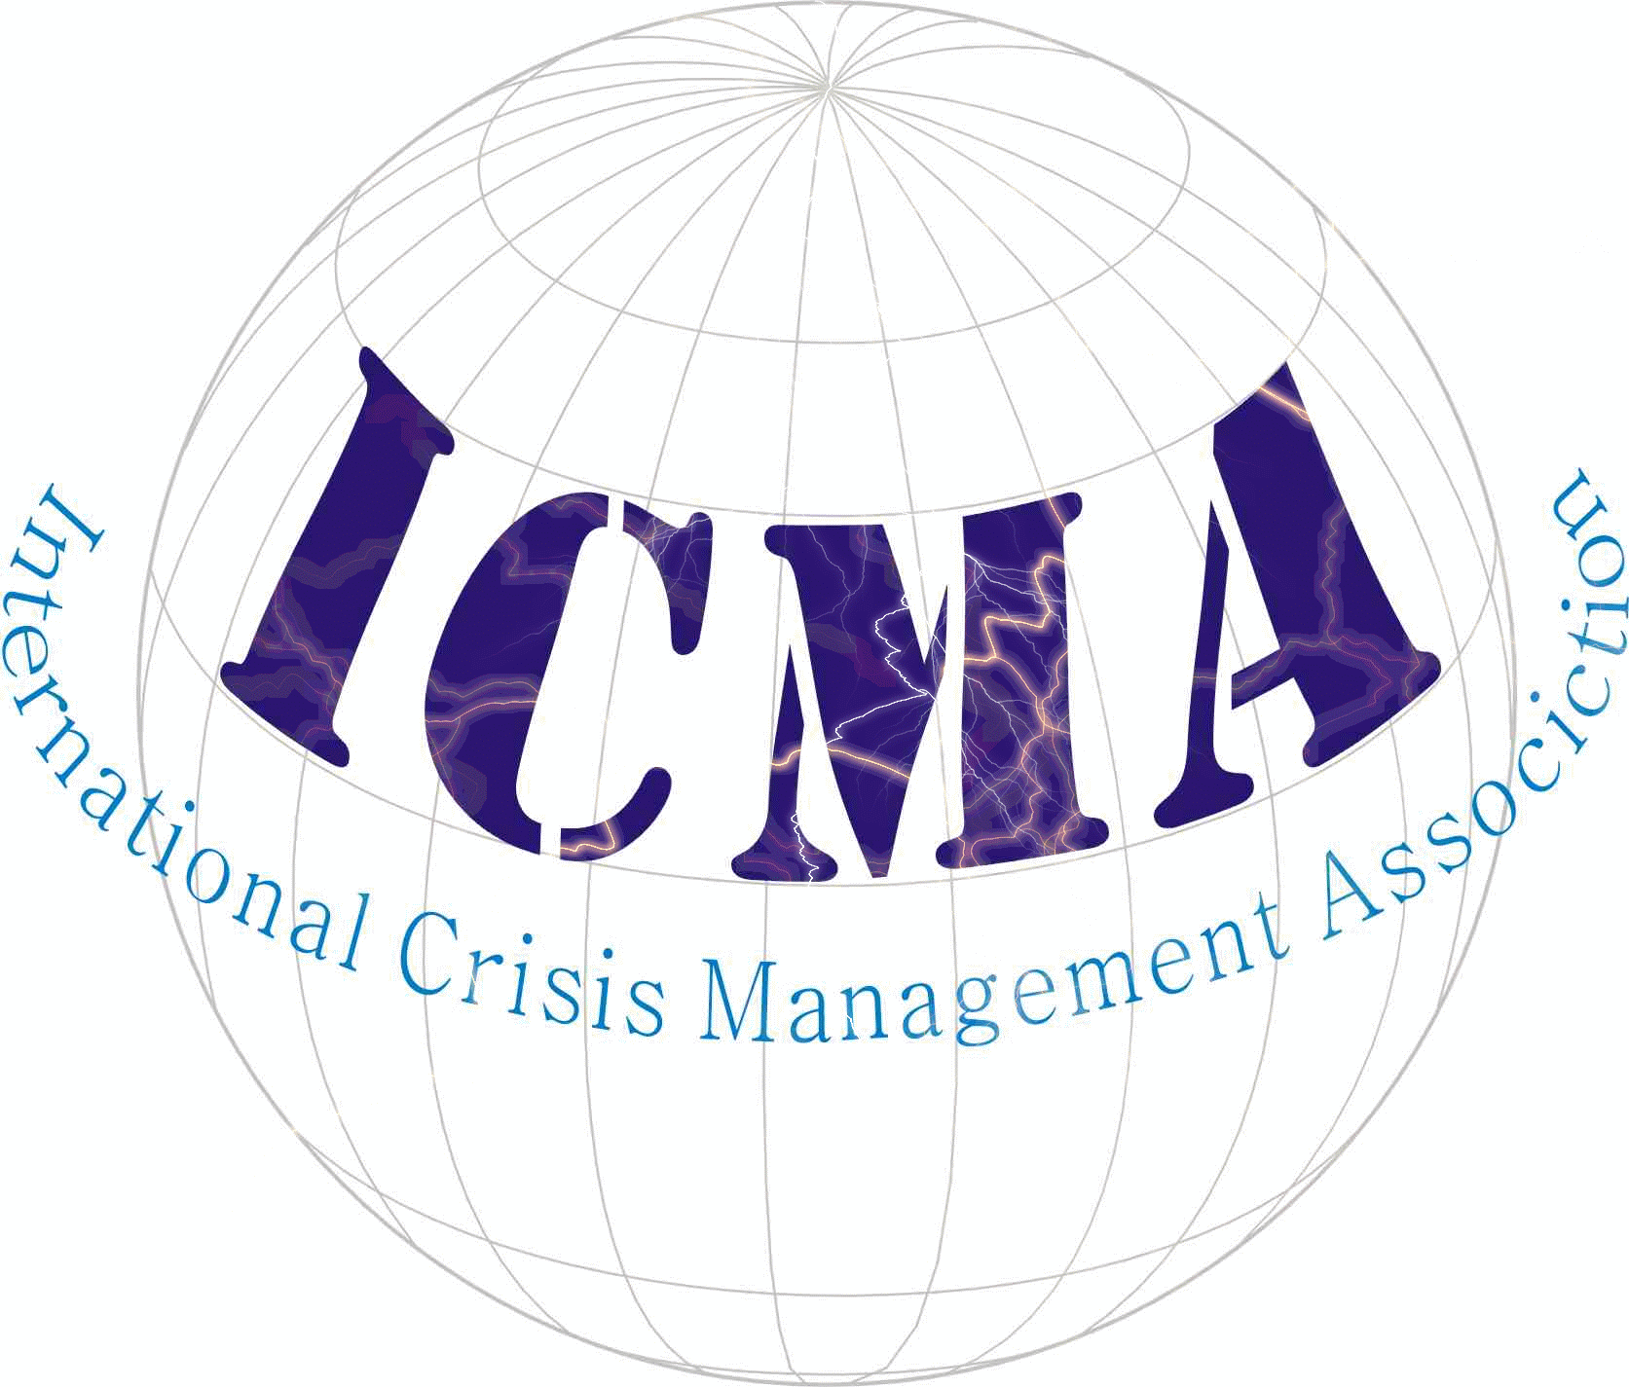
 | Application for CONSULTANT MEMBERSHIP *
Prof/Dr/Mr/Mrs/Ms
First name: |  |  |  | Last name:
Address:
Country:
Please indicate whether this is your home or work address: □ Home address □ Work address
Tel*: |  |  |  | Fax*:
* Please indicate country and city codes
E-mail:
Consultant Certificate:
Certificate No.:
Originally registered:
Latest issue:
Expiry Date:

Occupation*:
* Please List your main field of occupation.
Education:
Please list your most recent/highest level degrees/diplomas obtained; year granted and name of institution in which obtained:
Research:
Please list most recent research topics; field(s) of expertise:
Publications or Expertise:
Please list most recent publications (or expertise); year of publication and name of publisher
I hereby to declare that the above is a true statement:
(Place and date) |  | (Signature)

